165



-used to add audio

-HTMLAudioElement inherits properties from HTMLMediaElement

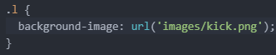 

-adding a background image to an area

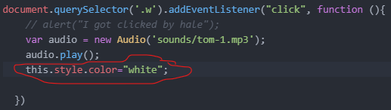

-changing the color of the button when it is clicked

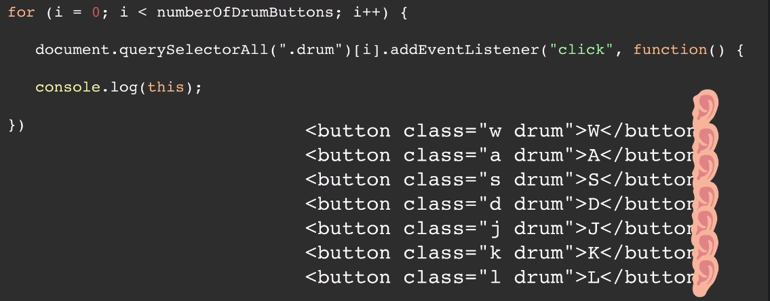

-prints what is on the right

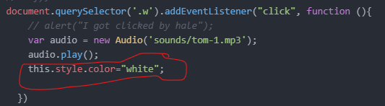

* Changing color using this

Using JS dictionaries

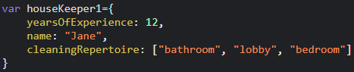



* You can use dictionaries and use “.” notation to access files

Constructor Function

-a way to avoid creating a new dictionary every time

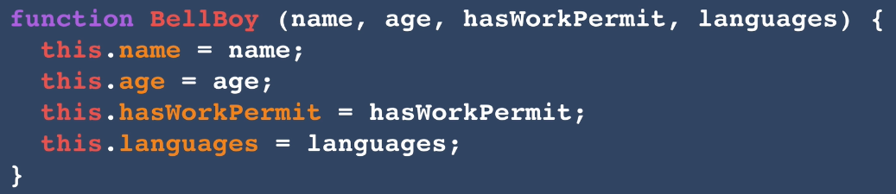

Initializing Object



JavaScript Switch statement

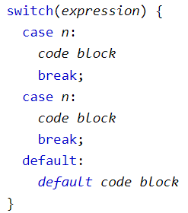

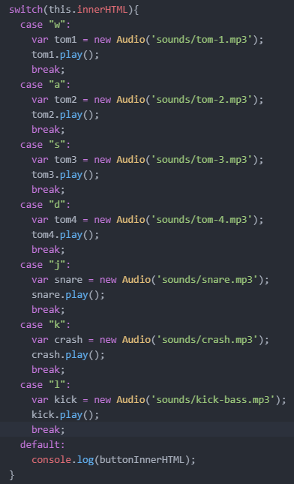

* When the expression is equal to one of the cases, that case will be executed
* The ‘break’ stops the execution of more execution of code and/or case testing inside the block. If ‘break’ is omitted, the next code block in the switch statement is executed.

Adding a Method to a Constructor

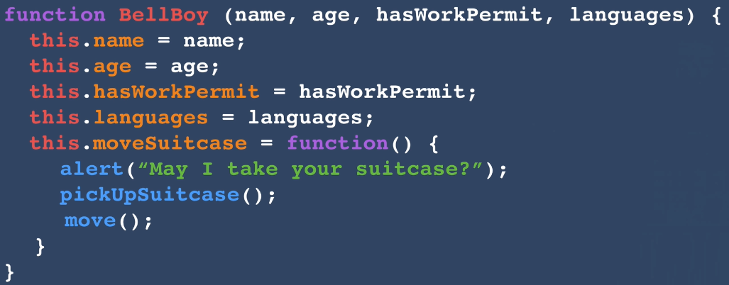

* + When we create an object using this constructor function, all of the objects will have the function associated with the moveSuitcase property.
  + We are assigning an anonymous function to the moveSuitcase property

Guessing what the object of  is like

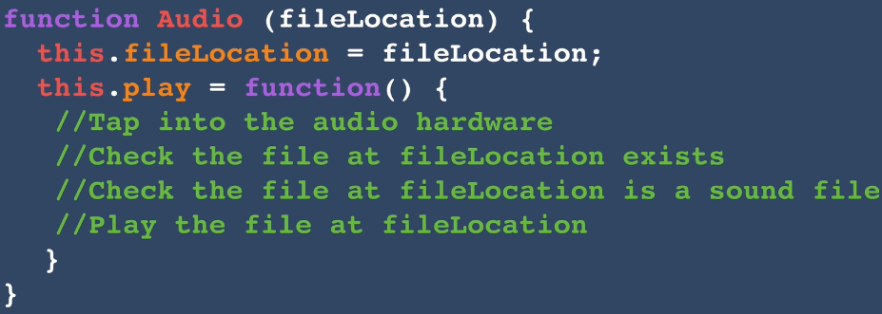

-Angela thinks the Audio constructor object looks like this